**Assignment 3**

**Aim**: Create a Website Using Bootstrap

**Code:**

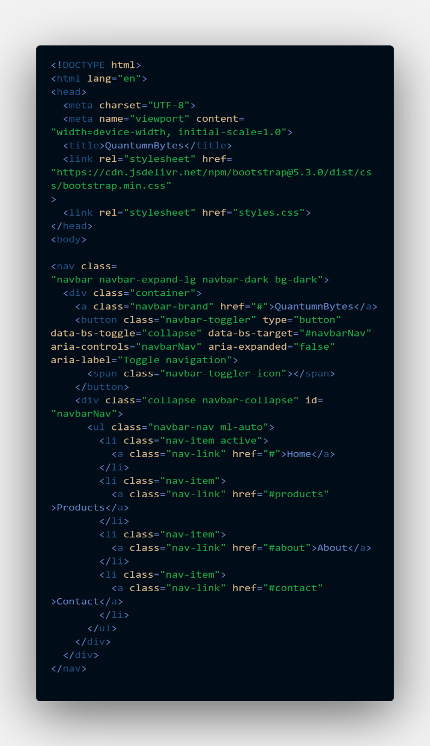

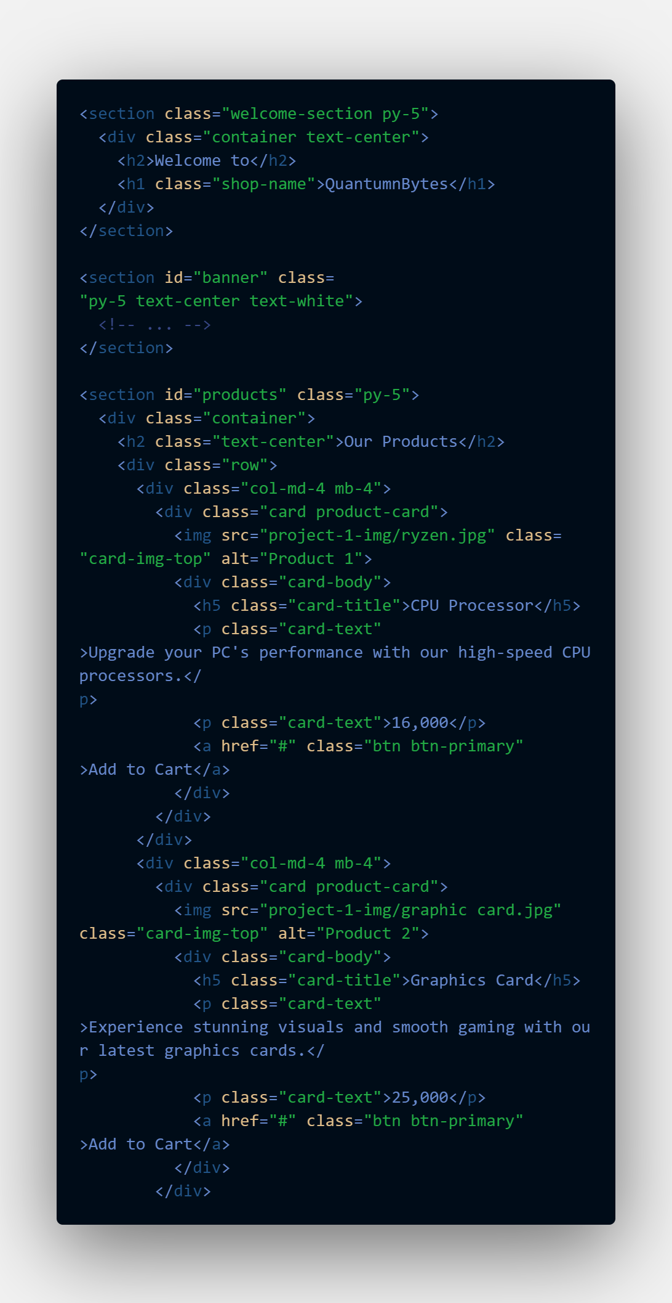

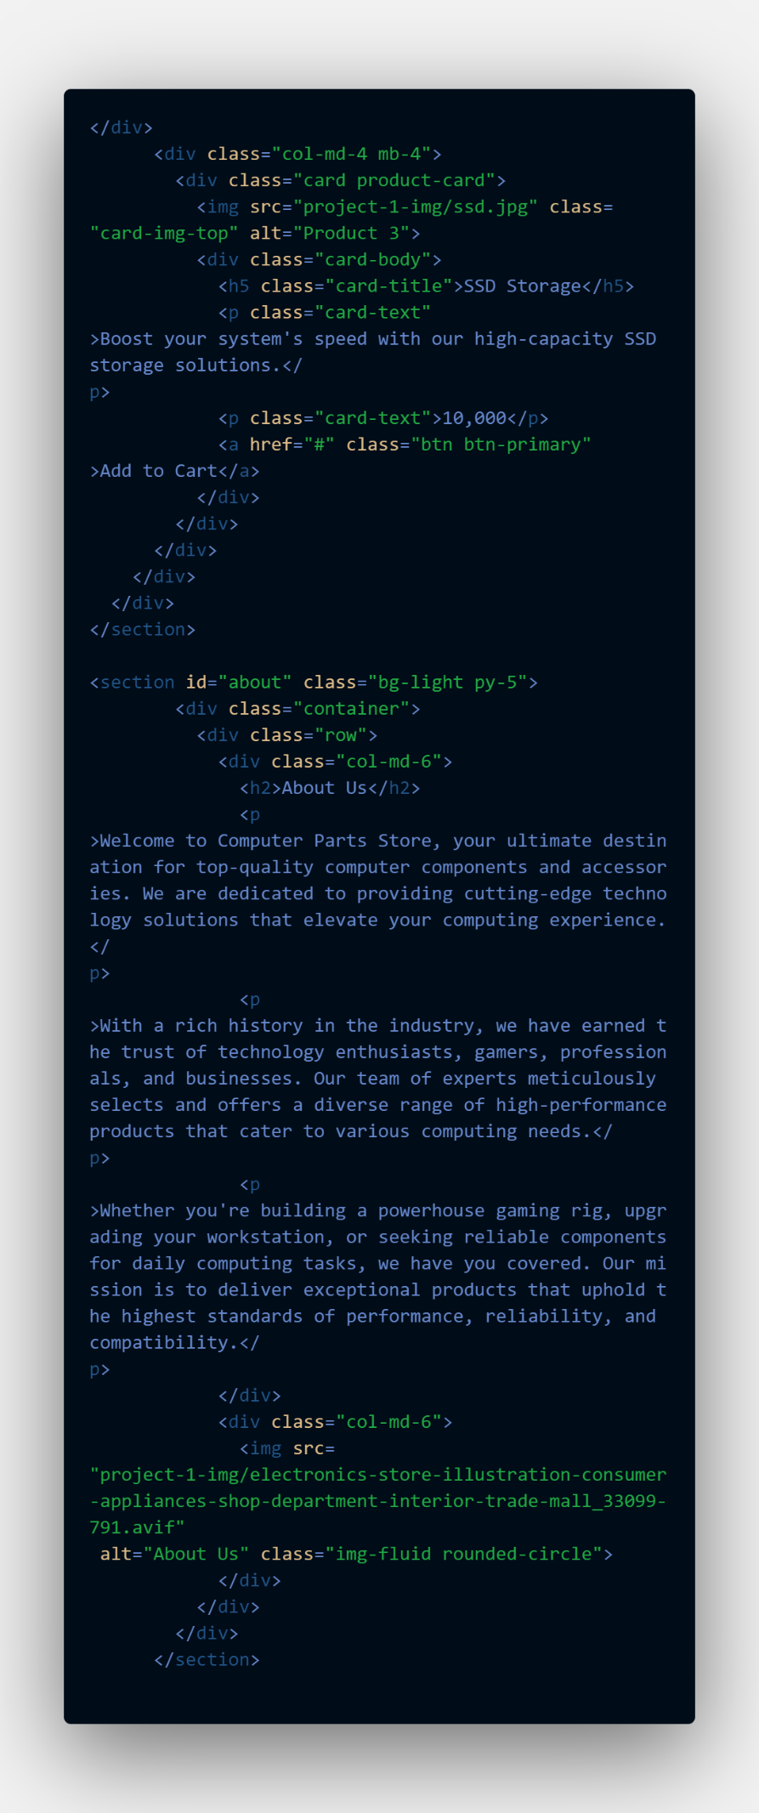

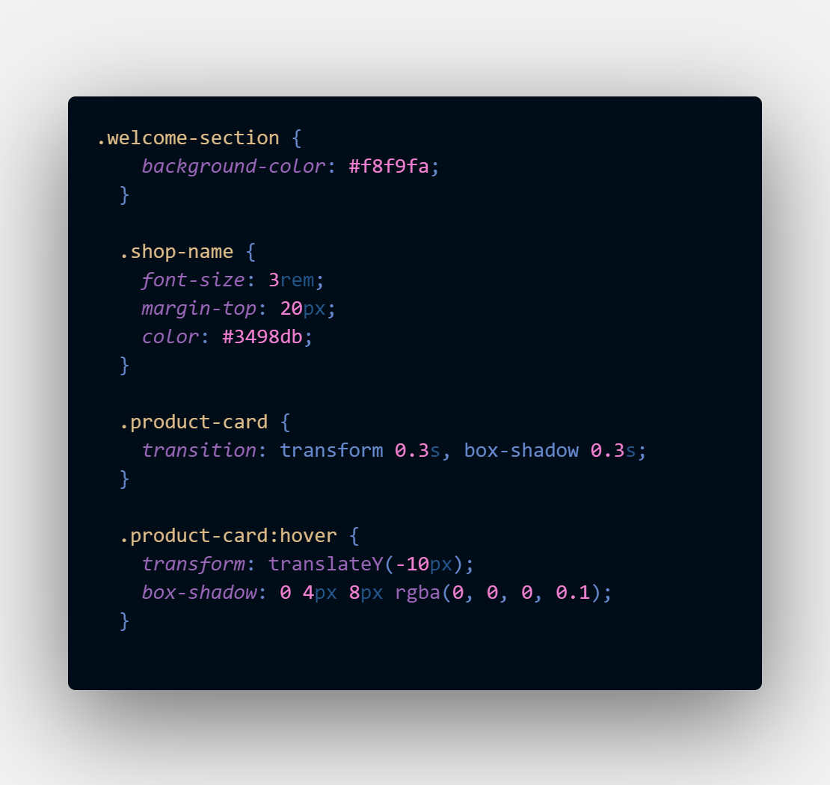

**Output:**

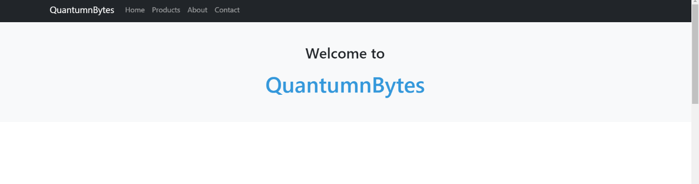

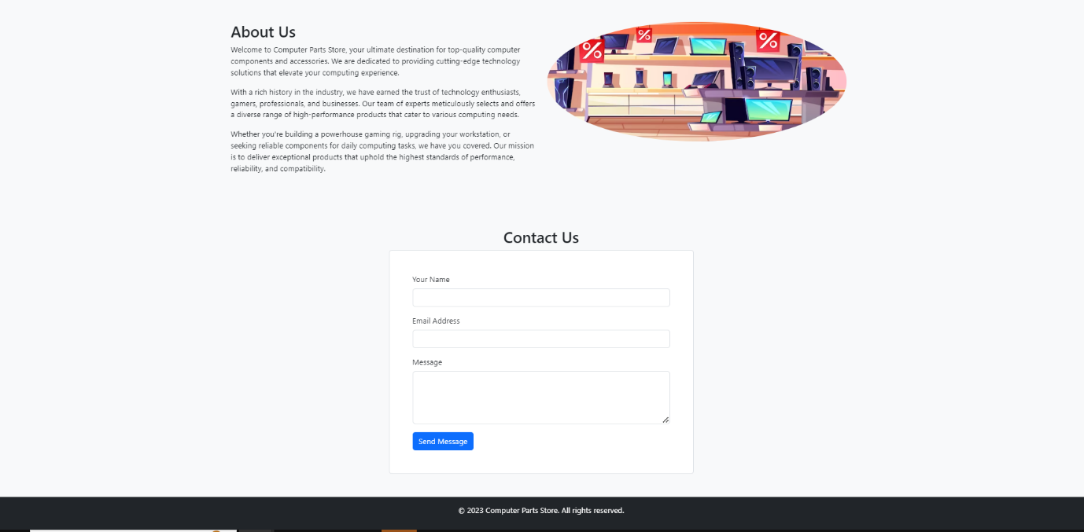

**Conclusion:**

The Following Website Landing Page Was Created Using

Bootstrap

The Component used are

**Bootstrap Components:**

1. Navbar
2. Card
3. Button
4. Container
5. Row
6. Column
7. Form
8. Responsive Text Alignment